**DETECTION & MITIGATION**

**It doesn’t come from an official Apple.com email address.**

Instead, the scammers have changed their “from name” to look like it’s from Apple (or “Apple ID”). Always click on or hover over the sender’s name to reveal their actual email address.

**There are subtle spelling and grammatical errors.**

Legitimate emails from Apple will almost never contain mistakes. Grammatical errors like “required”( instead of “requires”), “an unusual activity,” and no comma after “Sincerely” are signs that the email is fraudulent.

**The link takes you to a different URL than what’s shown.**

Scammers often change the display of links to make them appear more legitimate. You can hover over a link to see where it’s taking you. If you click on a link and the website that loads is different from what is noted in the link, leave the site immediately.

**There’s no personalisation**.

Usually, companies like Apple will greet you using your full name. Because they don’t have access to this information, scammers use generic greetings like “Dear friend” or “Dear valued customer.”

**It creates a sense of urgency by threatening to disable your Apple ID.**

Phishing scams try to use a false sense of urgency to make you act without thinking. Here, the scammer warns that there are only 24 hours to respond before the victim’s Apple ID is disabled.

**Always log in to your Apple account directly.**

Never click on links in emails. Instead, log in to your Apple account on AppleID.apple.com — or via the Settings app on your iPhone or iPad, or through iTunes on your Mac. If there’s an issue, you’ll be alerted as soon as you log in. If you see nothing, it’s a scam.

**If you click on a link, make sure it takes you to an official Apple.com web page.**

Scammers often mask the true locations of links in phishing emails. Click on the padlock symbol near the URL on a browser like Chrome or Safari to make sure that it’s “Apple.com” and that the security certificate is issued to Apple.

Caeser Cipher with 3-shift

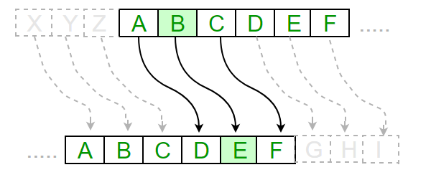

Caeser Cipher with 3-shift



Caeser Cipher with 3-shift



Caeser Cipher with 3-shift



Caeser Cipher with 3-shift



Caeser Cipher with 3-shift

Link to Caeser Cipher: <https://cryptii.com/pipes/caesar-cipher>



Caeser Cipher (Group 1)

Use the first letter of your answer and feed it to the 3-phase Caeser cipher.

Combination 1 (Hint: I am a city)

I stand tall and grand, in the heart of a city full of love.  
From my highest point, you can see the beauty of the city that surrounds me.

What am I?

Combination 2 (Hint: Part of a diet)

In the morning, I'm cracked with delight, a golden centre, a sunny sight. I transform in the kitchen and I hold the warm. I am fragile, though protected by a wall, yet I hold a new life.

Guess my name, I'm not that tall.

Combination 3 (Hint: An insect)

I buzz around in the bright summer sun. I like flowers and I mind my own business; though if bothered, I sting like stingray. On a bright side, I make a sweet treat, that is yummy, healthy and neat.

What am I?

Combination 4 (Hint: Fruit)

I'm a round and rosy friend, with a skin that's crisp and red. I grow on trees in orchards grand, and in pies and sauces, I'm well-fed.

What am I in the farmer's land?

Group 2:

Use the first letter of your answer and feed it to the 3-phase Caeser cipher.

Combination 1: (Hint: Sea and Ship)

In search of treasure, I roam the sea, A fearsome figure, wild and free. With a hat and a patch upon my eye, A map in hand, under the sky.

A cutlass sharp, a parrot squawks, On a ship with creaks and eerie talks. I bury gold on an island shore, X marks the spot, forevermore.

What am I?

Combination 2: (Hint: Role Model)

In the realm of tech, I take my flight, An entrepreneur with vision bright. Electric dreams and rockets high, Name a boundary, watch it fly. Innovation at my very core. A mind that travels to the stars, Known for ventures near and far. Cryptic tweets and memes so sly, A real-life Iron Man.

Who am I ?

Combination 3: (Hint: Sport)

I am bounced and dribbled, passed and shot. Through hoops, I'm aimed with precision. In courts and arenas, my presence you'll find, A game of teamwork and strategy aligned.

Combination 4: Hint: A place

A land of ice and snow, where penguins waddle and seals blow. The coldest place on Earth, they say, where the sun barely shines for a day. I'm the coldest of all, where few creatures roam, covered in ice, I'm a vast, white dome.  
Penguins slide, on my icy stage.

What place am I, on the world's page?.

